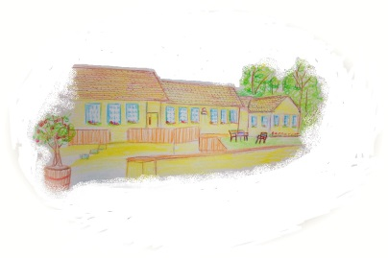
Scoil Náisiúnta Baile Uí Chárthaigh, Ballycar, Newmarket-on-Fergus, Co. Clare

October 2025 Newsletter

Energy Inventory took place on October 21st as instructed by the DES by RePower Energy to identify the base level conditions of each DES building which will be used to inform their delivery of a multi-annual investment plan for the energy retrofit of school buildings.

CPD
Gerianne Rigney – Edmark Reading Programme in the AEN/SEN
Carol Flannery – Understanding AUDHD Part 1
Understanding AUDHD Part 2
Anxiety and Neurodiversity
Understanding Pathological Demand Avoidance (PDA)
Visuals, Structure, and Predictability Without Rigidity
Amy Ryan – Self Compassion and Self Care for educators
Understanding ADHD
Anxiety and Neurodiversity
Mairead Burke - Anxiety and Neurodiversity
Epilepsy Awareness
Restorative Practice
Wellbeing Reimagined: AI Tools for Educators

Collection Times – Please collect your child from school on time every day. Junior and Senior Infants finish at 1.40pm and 1st to 6th class finish at 2.40pm. Staff have their own children to collect and often have CPD courses or meetings to attend in Clare Education Centre after school hours and are unable to wait at the school for children to be collected.

Astro-Turf Fundraising to date – Target of €75,000 reached!!!
Following the donation of all funds from the recent Tractor, Truck and Vintage Car Run organised by Sarah Lynch OBrien and the committee of the Newmarket on Fergus
Agricultural Show to the grand total of €5,650, our target has finally been reached and
surpassed.

Oscar Sports Capital Grant - €49,707
EI Electronics - €5,000
Solatrex International Ltd t/a Calcul - €100
NGS Engineering - €1,000
Cora Chaitlin Mens Shed - €500
Clare Oil - €50
Midwest Hearing Clinic – Noelle Meehan - €300
Smithstown Light Engineering - €200
Slaney O Brien Synott and Peter Synott, Zion Sport - €1000
IAC (International Aerospace Coating) - €250
K & J Townmore Construction Ltd, Kevin Enright - €250
Interpalace Investments Ltd/Cargo King- Sarah Lynch - €300
Infinity Lifts – Jag Sing/Erica Mc Guinness - €1000
HID Global - €500
Kerry Group - €100
Liffey Mills - €100
Ida and Pat Lynch - €500
John Lynch - €500
Sarah, Mark and Charlie O Brien - €300
Municipal District of Killaloe(Pat Burke & Alan O Callaghan - €5000
Nicole and Eoin Mulcahy - €500
Claire and William Ryan - €400
Ballycar Preschool/Boyce Plumbing - €1000
ABL Express Motors (N18 Motors) - €150
Hilda and Tony Jenkins - €1000
Elsevier - €900
Aine & John Galvin - €300
Sandra & Morgan McCarthy - €300
Tractor,Truck and Vintage Car Run - €5650
Robert Devitt, Tony O Sullivan, Chemifloc Ltd - €500
Total €77,357

Music Instrument Practice with Oisín’s Mam Nicole will take place every Thursday after the mid-term break in preparation for our Christmas concert.

Science Week takes place from November 9th to November 16th.

Mainstream Parent/Teacher Meetings will be taking place from Monday, November 10th to Friday, November 21st.

Belfield Infant Assessment Profile (B.IAP) will take place in November for all pupils in Junior Infants. Results/Feedback will be discussed with parents at Parent/Teacher meetings.

New School Website – www.ballycarns.ie will be officially launched and live in December.

Student Council organised a Halloween Fancy Dress Competition and Traditional Halloween Games for all pupils.

Christmas Concert – All pupils and staff wish to invite all family and friends to our Christmas Concert on Tuesday, Dec 16th at 6.30pm in the halla.

Christmas Cards are now finished and sent for sample printing.

Football – Hard luck to the girls football team, who lost their two games in this year’s Division 2 competition, to Kildysart N.S and an amalgamation of Ballynacally/Caherea/Clondrinagh N.S.

Semi-final -Well done to the boys who topped their group in Divison 4, beating Holy Family N.S, Cloughleigh N.S, Ruan N.S, Ennis Educate Together and Broadford N.S. The semi-final vs Liscannor N.S will take place in November.

Science Show for our 3rd to 6th classes will take place in Sixmilebridge N.S on the 6th of November. The senior classroom will attend between 11.15 and 12.30, lifts will be required to and from the event.

Clothes Collection took place on October 8th. A total of €126 was raised. Monies raised will go towards our Astro Turf fund.

Wishing all our pupils, staff and families a safe and happy Halloween break.
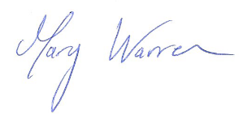
Yours sincerely,
__________________

